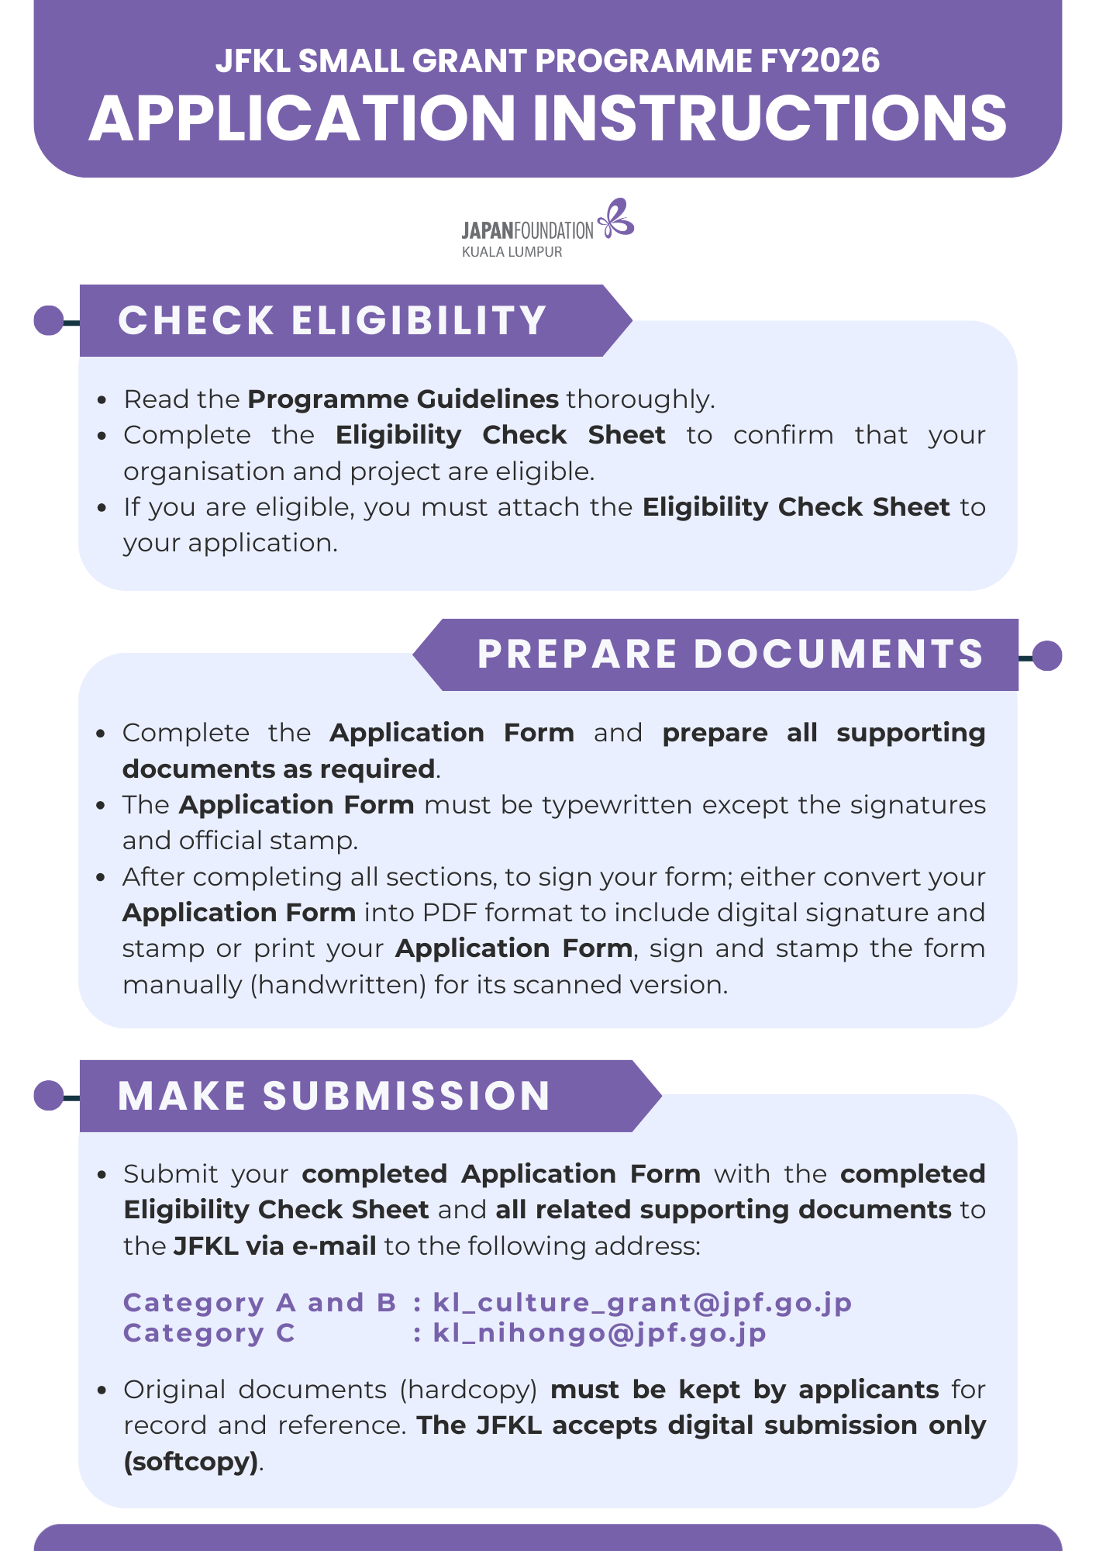


JFKL Small Grant Programme FY2026
Application Form

 | Date: |  |  |  |  |  |  |  | Click or tap to enter date of application
1. | Title of the Project:
 | Enter the title/name of your project
2. | Category of the Project:  Please check/choose relevant box
 | Category A: Japanese Arts and Cultural Exchange
 | o Performance |  |  |  | o Exhibition |  |  |  |  | o Film Screening
 | o Publication |  |  |  | o Other: Enter here
 | Category B: Japanese Studies and Global Partnerships
 | Conference/Seminar/Workshop/Masterclass |  |  |  |  |  | o Publication |  |  | o Other: Enter here
 | Category C: Japanese Language Education
 | o Conference |  |  |  | o Teacher Training |  |  |  |  | o Publication of Teaching Resources
 | o Support for Resource Centre/Library |  |  |  |  |  |  |  |  | o Other: Enter here
3. | Types of the Project:
 | o Physical |  |  |  | o Online |  |  |  |  | o Hybrid (Physical & Online)
4. | Project Period: The project must be organised/conducted between 1 April 2026 to 31 March 2027
 | From | Click or tap to enter your start date |  |  |  |  |  | To |  | Click or tap to enter your finish date
5. | Project Venue(s) / Online Platform(s):
 | State the venue or platform of your project
6. | Organisation Information:
 | Name of Organisation |  | : | Specify the name of your organisation in full
 | Name of Section that conducts the Project |  | : | (e.g., Division, Faculty, Department, Sector, etc.)
 |  |  | : | Specify the section in charge of this project under your organisation
 | Legal Status |  | : | Specify the legal status of your organisation
 | Registration Number |  | : | Enter the registration number of your organisation
 | Year of Registration |  | : | Enter the year of registration of your organisation
 | Office Address |  | : | Enter the full address of your organisation
 | Office Number |  | : | Tel: |  | Enter the phone number |  |  |  |  | Fax: | Enter the fax number

NOTE: PLEASE USE A SEPARATE SHEET WHEREVER NECESSARY
7. | Organisation Background:  For private organisation, please attach the registration certificate and recent audited financial report.
 | Write your organisation background
8. | Objectives of the Project:  Please state how your project can contribute to the objective of the grant.
 | Write the objectives of the project
9. | Project Description:  Please clarify how you plan to achieve the expected outcome described below through the proposed project.
 | *Please submit the detailed descriptions of the project (project proposal) and related supporting documents.

10. | Major Collaborators / Collaborating Institutions:  Please attach the supporting documents (i.e., Letter of collaboration, etc.) if possible.  Please include the support from any Japanese governmental organisations or agencies including the Embassy of Japan, Consulate-General of Japan and Consular Office of Japan, if any.
 | Country & Name of Institutions / Collaborators |  |  |  | Roles
 | Write the name of collaborators as detailed as possible |  |  |  | State the role(s) of each collaborator
11. | Proposed Schedule:  Please state the full schedule of your project including post-event (i.e., submission of final report, etc.)
 | Date/Period |  |  | Activities |  | Project Site / Venues / Platforms
 | Write the date/period as detail as possible |  |  | Write the activities/task/progress of your project |  | Write the site/venues/platforms of the activities
12. | Expected Output:  Please state how the project can contribute to the larger number of audience/participants & public.
 | Write the project expected outcomes
Continuation of Project:
Do you have plans for a different project as a continuation of, or related to this proposed project?
 | ☐ | YES | If yes, please state the plan(s) in general:
 | ☐ | NO | Write your future plans, if any e.g. name of project, content, date, venue, etc.

13. | Public Relation (PR) plan for both before and after the project implementation:
 | Write your PR plan as detailed as possible
*Checklist for Ticketing Events:
Complete this section if relevant to your project.
 | Event | Ticket Price / Participation fees |  |  | Number of estimated audiences
 | 1. Event name | Adult | : | RM Amount | No. of people
 | 1. Event name | Concessions | : | RM Amount | No. of people
 | 2. Event name | Adult | : | RM Amount | No. of people
 | 2. Event name | Concessions | : | RM Amount | No. of people
 | 3. Event name | Adult | : | RM Amount | No. of people
 | 3. Event name | Concessions | : | RM Amount | No. of people
 | Total number of estimated audiences: |  |  |  | No. of people
 | Will you apply for visa for the artist & permit for performance? |  |  | o Yes | o No, because:
 |  |  |  | o Yes | If no, state the reason(s) here

14. | Budget Proposal (In Ringgit Malaysia)  SAMPLE  All budget items for the project, including those covered by the applicant and other funding sources, should be included in the Project Total Cost.  All cost should be stated only in Ringgit Malaysia (MYR), including for applicants from Singapore and Brunei by referring to MUFG current conversion rate.
Each cost breakdown must be written clearly.  Specify each item as detailed as possible.  (A) FULL COST FOR PROJECT |  |  |  |  |  | (B) BREAK DOWN OF COST SHARING (MYR)  Cost coverage and in-kind support
 |  |  |  |  |  | Minimum 20% of the full cost |  | Maximum 80% of the full cost
Items |  | Specification | Cost Breakdown | Total Cost (MYR) |  | Applicant’s Own Expenses | Other Funding Sources | Grant from JFKL
(1) | Honorarium | Speaker 1: Dr. Yoshida Masayoji  Speaker 2: Ms. Sakura Kyo | RM 1,000.00 X 1 day X 2 speakers | 2,000.00 | → |  | 1,000.00 | 1,000.00
(2) | Per diem | Speaker’s daily meals | RM 100.00 X 1 day X 2 speakers | 200.00 | → |  | 200.00
(3) | Transportation | Route, Class, etc. | Dr. Yoshida: RM 3,489.00 (Roundtrip)  Dr. Sakura: RM 3750.00 (Roundtrip) | 7,239.00 | → |  | Quotation/invoice/etc for all cost to be covered under JFKL must be attached with this application form. | 7,239.00
(3) | a. International | Dr. Yoshida: MAS (economy)  01 May 25: NRT-KUL- MH9117  04 May 25: KUL-NRT MH70  Dr. Sakura: Air Asia (economy)  01 May 25: KIX-KUL- D7533  04 May 25: KUL-KIX -D7532
(3) | b. Domestic  (within Malaysia) | Grab (roundtrip):  Cititel Mid Valley - Dewan Seri Negeri for rehearsal and event day | RM 30.00 X 4 trips | 120.00 | → | 120.00
(4) | Accommodation | Hotel Cititel Mid Valley: Deluxe Room  01 May 25- 04 May 25 | RM 250.00 X 3 nights X 2 speakers | 1,500.00 | → |  |  | 1,500.00
(5) | Publicity / PR | Facebook paid advertisements:  01 April-15 April | RM 40.00 X 15 days | 600.00 | → | 600.00
(6) | Fee for rental of venue & equipment | Venue: Dewan Seri Negeri  01 May 25 (max: 500 pax)  Equipment: PA system and projector | RM 4,000.00 X 1 day  RM 1,000.00 X 1 day | 5,000.00 | → |  | 1,000.00 | 4,000.00
(7) | Report / Printing | Event flyers (A5)-full colour  Event posters (A3)- full colour | RM 1.50 X 100 pieces  RM 2.00 x 10 pieces | 170.00 | → | 170.00
(8) | Fee for visa and permit |  |  |  | →
(9) | Fee for translator / interpreter | Interpreter: Ms. Aina Nabila  2 days | RM 100.00 X 5 hours X 2 days | 1,000.00 | → | 1,000.00 | Total amount under JFKL grant must be lesser than 80% of overall cost.
(10) | Others |  |  |  | →
Project Total Cost: |  |  |  | 17,829.00 | → | 1,890.00 | 2,200.00 | 13,739.00

14. | Budget Proposal (In Ringgit Malaysia)  All budget items for the project, including those covered by the applicant and other funding sources, should be included in the Project Total Cost.  All cost should be stated only in Ringgit Malaysia (MYR), including for applicants from Singapore and Brunei by referring to MUFG current conversion rate.
(A) FULL COST FOR PROJECT |  |  |  |  |  | (B) BREAK DOWN OF COST SHARING (MYR)  Cost coverage and in-kind support
 |  |  |  |  |  | Minimum 20% of the full cost |  | Maximum 80% of the full cost
Items |  | Specification | Cost Breakdown | Total Cost (MYR) |  | Applicant’s Own Expenses | Other Funding Sources | Grant from JFKL
(1) | Honorarium | Click or tap here to enter text. | Click or tap here to enter text. | 00.00 | → | 00.00 | 00.00 | 00.00
(2) | Per diem | Click or tap here to enter text. | Click or tap here to enter text. | 00.00 | → | 00.00 | 00.00 | 00.00
(3) | Transportation | Route, Class, etc. | Click or tap here to enter text. | 00.00 | → | 00.00 | 00.00 | 00.00
(3) | a. International | Click or tap here to enter text.
(3) | b. Domestic  (within Malaysia) | Click or tap here to enter text. | Click or tap here to enter text. | 00.00 | → | 00.00 | 00.00 | 00.00
(4) | Accommodation | Click or tap here to enter text. | Click or tap here to enter text. | 00.00 | → | 00.00 | 00.00 | 00.00
(5) | Publicity / PR | Click or tap here to enter text. | Click or tap here to enter text. | 00.00 | → | 00.00 | 00.00 | 00.00
(6) | Fee for rental of venue & equipment | Click or tap here to enter text. | Click or tap here to enter text. | 00.00 | → | 00.00 | 00.00 | 00.00
(7) | Report / Printing | Click or tap here to enter text. | Click or tap here to enter text. | 00.00 | → | 00.00 | 00.00 | 00.00
(8) | Fee for visa and permit | Click or tap here to enter text. | Click or tap here to enter text. | 00.00 | → | 00.00 | 00.00 | 00.00
(9) | Fee for translator / interpreter | Click or tap here to enter text. | Click or tap here to enter text. | 00.00 | → | 00.00 | 00.00 | 00.00
(10) | Others | Click or tap here to enter text. | Click or tap here to enter text. | 00.00 | → | 00.00 | 00.00 | 00.00
Project Total Cost: |  |  |  | 00.00 | → | 00.00 | 00.00 | 00.00

15. | Bank Account:  In case the name of the account holder differs from the name of the applying organisation, a letter of attorney which describes the reason of delegation in needed if JFKL decides to award the grant.
 | Bank Name |  |  |  |  | : | Name of bank in full
 | Branch Name |  |  |  |  | : | Name of branch (location)
 | Address |  |  |  |  | : | Address of bank
 | Account Number |  |  |  |  | : | Account number
 | Bank Code / IBAN for 24 European Nations |  |  |  |  | : | Click or tap here to enter text.
 | Bank Code / BIC / Swift Code for 24 European Nations |  |  |  |  | : | Click or tap here to enter text.
 | Name of the Account |  |  |  |  | : | Name of the account holder (organisation/institution)
 | Address of the Account |  |  |  |  | : | Address of the account
16. | Endorsement:  The Contact Person and the Project Director may be the same individual.  However, the Project Director and the Bursar must be two different individuals.
 | (A) Contact Person
 | Name |  | : | Full name with title
 | Position/Designation |  | : | Position/designation of the contact person in the organisation
 | Contact Number |  | : | Tel: |  |  | Enter the phone number | Fax: | Enter the fax number
 | E-mail Address |  | : | E-mail address of the contact person for correspondence
 | Signature |  | :
 | ☐ | This Contact Person is also the Project Director *If checked, not required to fill in (B) Project Director below
 | (B) Project Director |  |  |  |  |  |  |  |  |  | OFFICIAL STAMP
 | Name |  | : |  | Full name with title |  |  |  |  |  | OFFICIAL STAMP
 | Position/Designation |  | : |  | Position/designation of the project director in the organisation
 | E-mail Address |  | : |  | E-mail address of the project director
 | Signature |  | :
 | (C) Bursar
 | Name |  | : |  | Full name with title
 | Position/Designation |  | : |  | Position/designation of the bursar in the organisation
 | E-mail Address |  | : |  | E-mail address of the bursar
 | Signature |  | :

Application Documents:
Please ensure to complete all sections of this application form and attach all related supporting documents.
Confirm the checklist below before submitting your application to JFKL:

JFKL SMALL GRANT PROGRAMME FY2026
APPLICATION CHECKLIST
No. | Document | *Related section in Application Form | ☒
1. | Application form (this document) |  | ☐
2. | Eligibility check sheet |  | ☐
3. | < Supporting Documents >
(i) | Organisation’s registration certificate, recent audited financial report | No. 7 | ☐
(ii) | Information on the applicant’s organisation | No. 7 | ☐
(iii) | Detailed project proposal (including a report of past similar project, if any) | No. 8, No. 9, No. 11, No. 12, No. 13, No. 15 | ☐
(iv) | Profile, biography or CV of guest/collaborator (artist, researcher, collaborating institutions, etc.) | No. 10 | ☐
(v) | Agreement with the guest/collaborator (in a form of a letter, e-mail or contract) | No. 10 | ☐
(vi) | Quotations, proforma invoice or any written forms to prove the cost as per request in the budget proposal | No. 15 | ☐
(vii) | Other:  State the document here |  | ☐
(vii) | Other:  State the document here |  | ☐
(vii) | Other:  State the document here |  | ☐
(vii) | Other:  State the document here |  | ☐
(vii) | Other:  State the document here |  | ☐
(vii) | Other:  State the document here |  | ☐
*Applicant must complete all related section in the application form AND attach the supporting documents.

Kindly mark related box(es):
How or where did you discover this grant opportunity?
☐ | JFKL website | ☐ | Friend
☐ | JFKL Facebook | ☐ | Colleague or own organisation/institution
☐ | JFKL Instagram | ☐ | Japanese organisations/agencies
☐ | JFKL newsletter | ☐ | Social media (other than JFKL)
☐ | JFKL staff | ☐ | Other: State the platform etc.

